As User Group organisers, it becomes difficult for us to track the attendance of participants mostly due to the format of the meeting. In our last week's UG we were prepared to break the ice and created an app to check in attendees.

**Following is what you can do with the app:**

1. Register attendees as members
2. Update member details
3. Check In attendees
4. Draw Raffle (if and when it's available)

**What can you get out of it:**

1. Track the attendance of your members
2. If members are not regular, send them a survey for what they want to see
3. Send them a FormsPro survey to get feedback
4. Keep member details up to date
5. Instead of drawing raffle the conventional way, use PowerApps

**Screens:**

**Home**



**Register Participant**

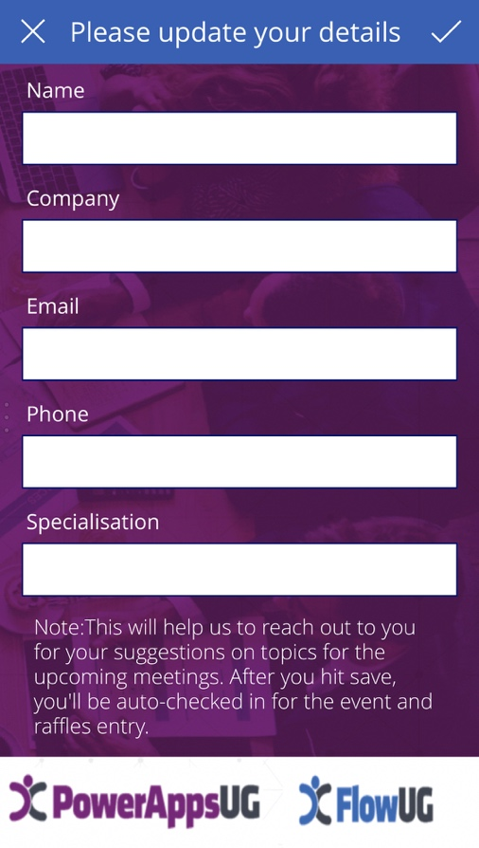

**Update Details and Check In**

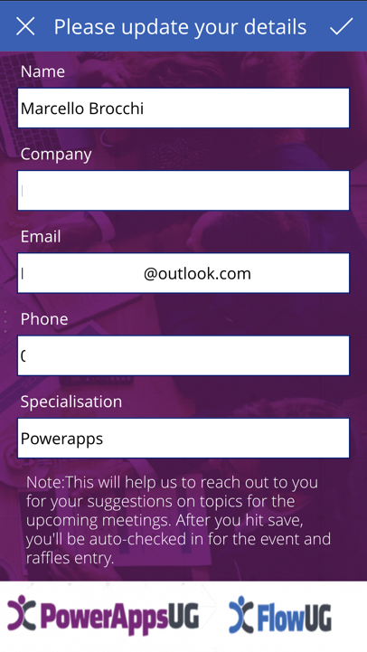

Note: Check In form is hidden, so members don't have to fill in date, UG and their name again

**Members List**

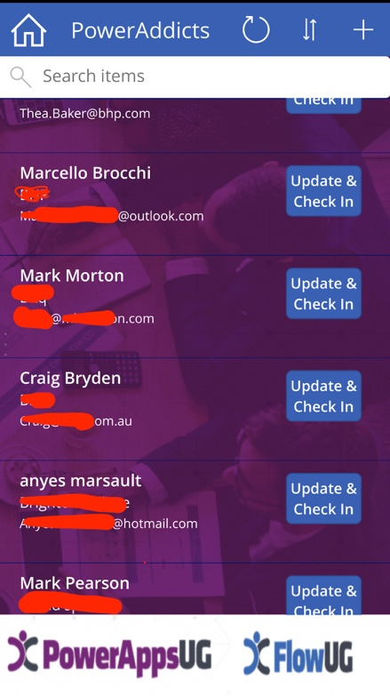

**Draw Raffle**

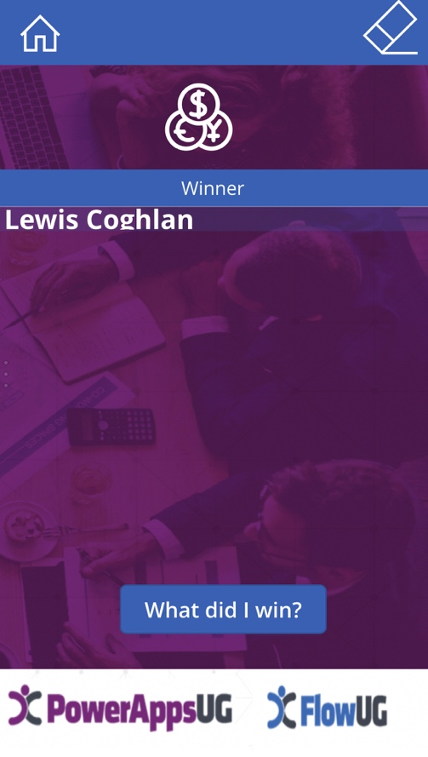

Note: Shuffle formula and collection is used for Raffle draw

**Data Source:** OneDrive (Excel Web)

**Tables used:** Registered Members and Checked In Members to draw raffle

If you're a User Group leader and want to use this app; you don't really have to make any changes except for the connection and start using it. I have uploaded it on github.